1.

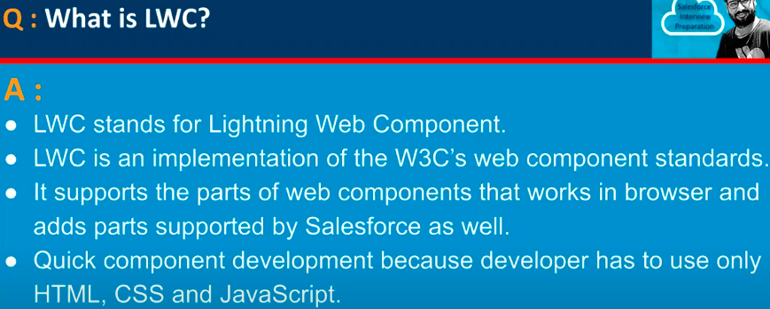

2.

3.

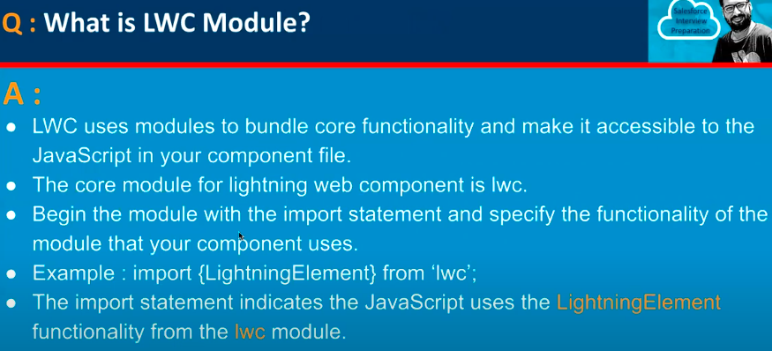

4.

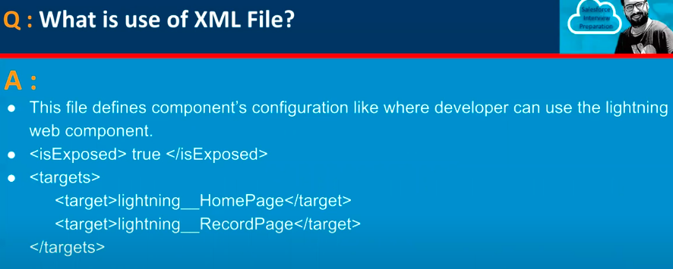

5.

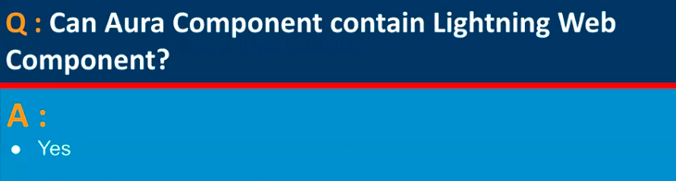

6.

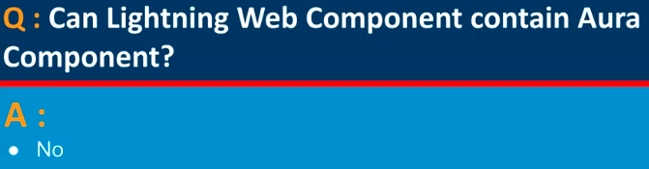

7.

8.

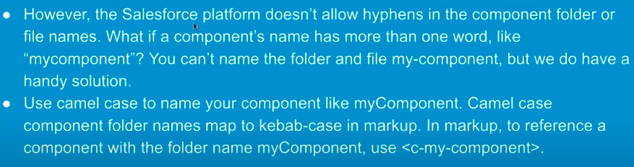

9.

10.

11.

12.

13.

14.

15.

16.

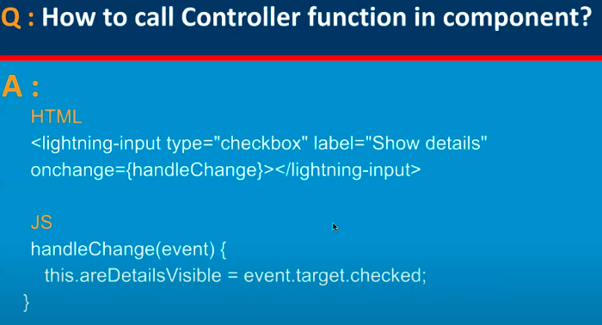

17.

18.

19.

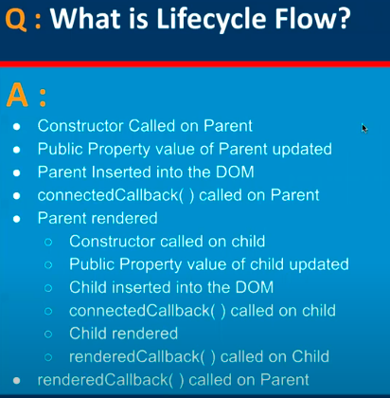

20.

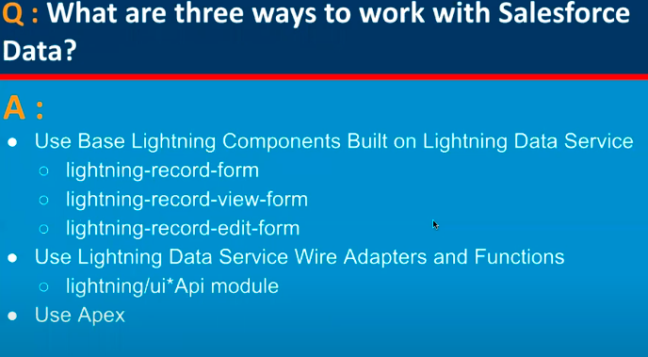

21.

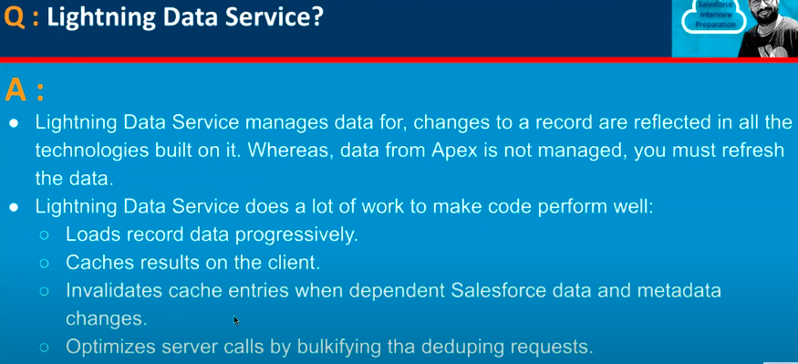

22.

23.

24.

25.

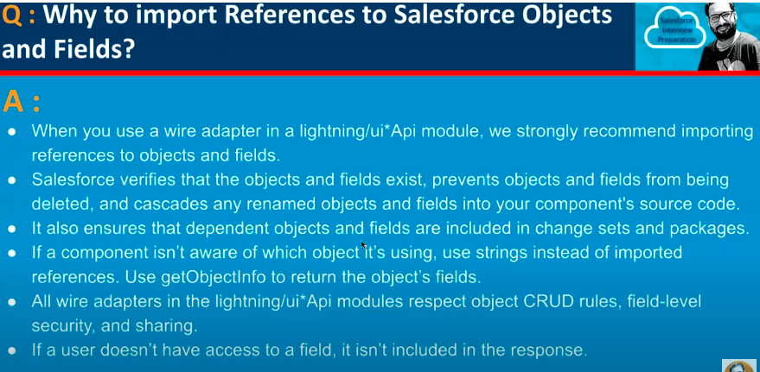

26.

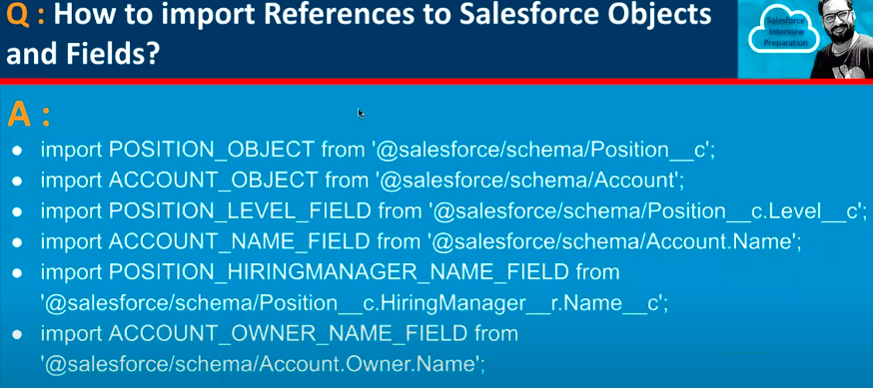

27.

28.

29.

30.

31.

31.

